Television and the Telephot

May - June 1918

**DRAFT:** *Please do not share without permission of the author. Typeset versions in* [*web*](http://gernsback.wythoff.net/191805_television_and_telephot.html) *|* [*pdf*](https://github.com/gwijthoff/perversity_of_things/blob/gh-pages/typeset_drafts/191805_television_and_telephot.pdf?raw=true) *|* [*doc*](https://github.com/gwijthoff/perversity_of_things/blob/gh-pages/typeset_drafts/191805_television_and_telephot.docx)

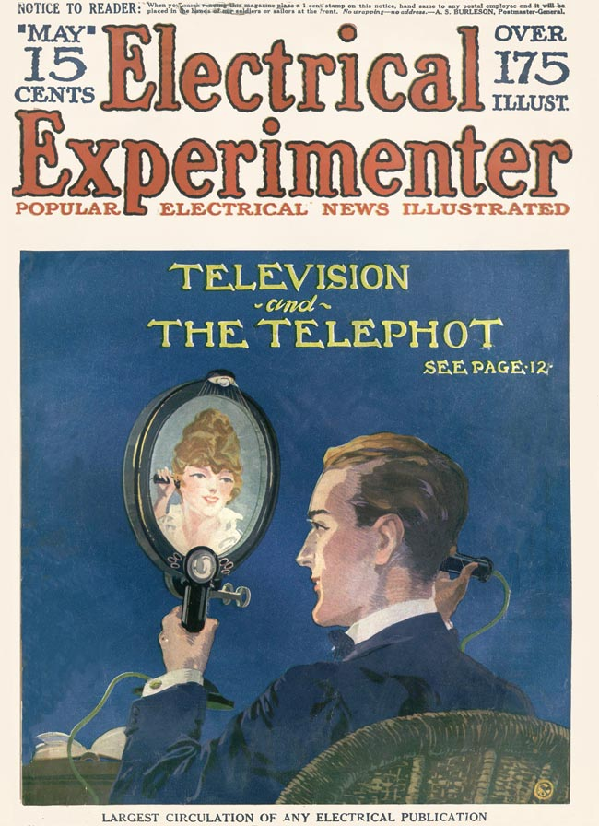

# Part 1

THERE are certain inventions which, altho not as yet existent, we may take for granted will be invented some day without any doubt whatsoever. While the layman may not believe in the science of prediction, still there are quite a few things in physics that can be prophesied ahead of time quite safely. There are many inventions which have been predicted in the past and which are quite certain to be realized in the not too distant future. That they have not already appeared is by no means the fault of science, speaking generally, but simply because certain minor phases in the various endeavors have not as yet advanced sufficiently to make such inventions possible. A point in case:

Jules Verne, almost fifty years ago, predicted the submarine down to the last bolt. His prediction, of course, was laughed at and called impossible. At that time it was impossible, for the simple reason that the technique had not advanced sufficiently to make such a boat possible. Furthermore, Jules Verne had quite a clear conception how the ultimate submarine would be constructed, and he so described it in his marvelous book, “20,000 Leagues Under the Sea.” Of course, in those days the internal combustion engine had as yet not been invented, which was one of the chief drawbacks and which is the reason that at that time the submarine was not feasible. Neither had the storage battery been invented, and Jule Verne’s idea of propelling a sub-sea boat by means of primary batteries alone, while feasible on paper, was not practical.

Another case in point is that of the planet Neptune, which had never been dreamt of until Le Verrier, the famous French mathematician, in 1846, by mathematical deductions, not only predicted that there must be another planet beyond Uranus, but he also predicted—on paper—just where in the heavens the planet might be found. His prediction proved correct, and the planet Neptune was indeed found almost exactly in the region where Le Verrier had deducted that it must gravitate. This was one of the most astounding scientific predictions ever made, but this instance, of course, was founded upon the exact science of mathematics.

Another case in point is that we know to-day that our list of elements is not quite complete. There are several gaps as yet of certain elements which have never been seen by man. Not only do we know that there must exist such elements, but we also know the physical properties of them, should they be discovered some day, which no doubt they will. When we therefore make the assertion that certain inventions are coming, we make it on a safe, scientific ground, because such discoveries surely will be made without doubt.

The subject of the present article “Television, or Seeing at a Distance,” is one of these inventions. Numerous inventors have busied themselves trying to invent an apparatus or machine whereby it would be possible for one person to see another while talking on the telephone, but so far nothing practical has resulted. The future instrument on which the name “Telephot” (from the Greek tele-is.r, photos-light) has been settled, is supposedly an apparatus attachable to our present telephone system, so that when we speak to our distant friend, we may see his likeness not only as an immovable picture, but we will see his image exactly as we see our own image when looking into a mirror. In other words, the apparatus must faithfully follow every movement of our distant friend whether he is only five blocks away or one thousand miles. That such an invention is urgently required is needless to say. Everybody would wish to have such an instrument, and it is safe to say that such a device would revolutionize our present mode of living, just as much as the telephone revolutionized our former standard of living.

Most inventors who had been working in the past on this problem, failed to bear in mind a very important consideration.

If the Telephot is ever to be a success, it must of course be possible to attach it to the present-day telephone lines. That means that the instrument must of necessity work in conjunction with the telephone without necessitating any more wires than there are used now. As everyone knows, the subscriber’s telephone is connected with two wires to the central station. Each telephone instrument therefore requires two wires, or otherwise one metallic wire, and the ground for a return “wire,” which is the same thing as two wires. Over these two wires to-day, we do not only speak, but “Central” also rings your bell. In the case of a “pay-station” telephone, quite a few more functions are accomplished over these two same wires. It is also possible to-day to telegraph and telephone simultaneously over two wires neither one or the other being affected. Why then should it not be possible to also send translated light impulses over these two wires at the same time that the voice impulses are translated over them?

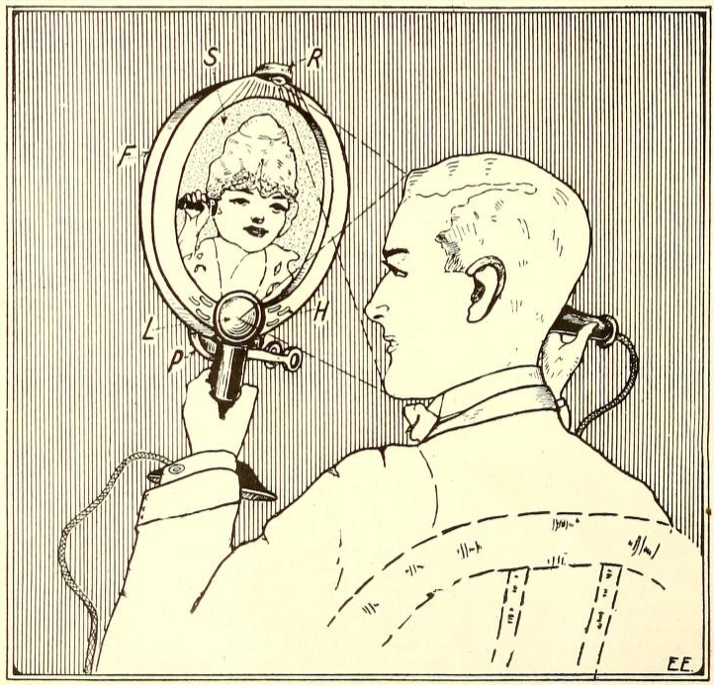

What the Future Telephot Will Look Like in Order to be Practical. Light R Throws Light on Speaker’s Face and is Reflected Into Lens L. Instead of a Mouthpiece, the Holes H of the Sensitive Transmitter Inside of Frame F Pick Up the Speech. The Picture of the Distant Person Appears on Screen S.

In most of the schemes offered by inventors heretofore, a plurality of wires was necessary ; in some cases several thousand pairs of wires. No matter how well such an instrument might work, this alone would doom it to certain failure. Another point is that the future Telephot must not be a cumbersome machine requiring motors and all kinds of other cumbersome machinery, difficult to operate by the layman.

The future instrument must work the same as the telephone. In other words, all the subscriber has to do is to lift the receiver off the hook, and he will immediately see his friend just as if he were talking to him in the same room. All these requirements may seem hard on the inventor, but they are absolutely necessary as a simple reflection will show.

The writer also ventures to say that no Telephot will ever amount to anything that necessitates the use of selenium. As is well known in nearly all past suggested television schemes, the selenium cell in one form or another was used. The underlying idea of these schemes is that light rays of the object striking the selenium cell varies the resistance of the same, and these various impulses are then sent over the line to be translated into a picture by various means and manners at the receiving end. The trouble with the selenium cell is that it is not sensitive enough, and on account of its inertia does not work fast enough. Also in most of the proposed television schemes, a multitude of selenium cells is required, which again means a plurality of wires, thereby dooming the scheme at once. There must be something else besides selenium that can translate light impulses into electric impulses. Indeed, such a scheme is already existent, nature having worked it out millions of years ago. And while it is not electrical, it illustrates what we are driving at.

The animal eye is the most marvelous television apparatus ever invented. Moreover, it is non-electrical. If we look at an object, the latter is thrown into our eye, which is nothing but a marvelously efficient camera, but instead of a photographic plate, the impulses are thrown up on the Retina which records the object, not only in black and white as does the photographic plate, but the picture is recorded in its natural colors on the retina. From here numerous fine nerve strings interlocked in the retina connect with the optical nerve, which nerve in turn connects with the occipital lobes of the brain, translating the various light impulses, {stimuli) with their component colors into a “picture,” which is then “seen” in our mind. We say “seen” advisedly, because of course the picture is not actually seen in the mind, but the impulses which the retina has picked up are translated into another form, which we experience in turn as the sensation of seeing.[1]

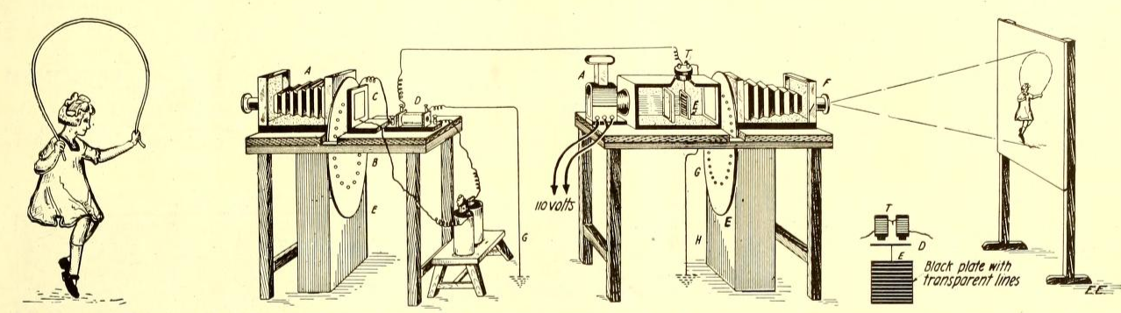

The Dussaud Telephot Uses Two Perforated Discs B Revolving Synchronously. The Holes are Arranged Helically; thus Every Point of the Picture is Covered During One Revolution of the Disc. Selenium Cell C Transmits Impulses to Receiver T, which Vibrates Plate E. The Latter Only Passes Parallel Rays of Light. With this Machine It Is — Theoretically— Possible to Transmit Objects In Motion, Electrically.

As has been shown experimentally, the picture is retained on the retina for about one-tenth of a second. This is called the persistence of the image. It is this phenomenon which is made use of in moving pictures, each successive picture staying on the screen for a tenth of a second before the next one is flashed on. The fact that the pictures follow each other so rapidly, gives tha impression on the retina that the objects are moving on the screen, which of course they do not.

Now, as we have shown that pictures can actually be transmitted at a distance[2] without the means of selenium cells, it is up to our inventors to devise something to do away with these cells entirely. It is safe to say that when the successful Telephot finally appears, it will be found to be a very simple apparatus, probably not much more complicated than the presentday telephone receiver.

When one considers how many different functions the diafram in a telephone receiver performs, it seems that it should be a simple matter to translate light impulses into electrical impulses. Just stop and consider that a single telephone diafram can pick up several hundred pure notes as well as several thousand distinct kinds of noises, which in turn are translated into electrical impulses. These impulses are then sent over the line only to be re-translated faithfully into the same notes and noises at the other end of the line, using nothing but a single diafram on another telephone receiver. Before the telephone was invented, it was thought that for each note, a diafram or vibrating reed was necessary. Strange to relate however, a single diafram records the human voice vibrations so faithfully that it is possible to recognize a friend’s voice readily over the telephone as is done every day ; this is quite an amazing fact, if one stops to think of it. For in order to recognize a friend’s voice, it is not only necessary to transmit the various sounds, but also all the overtones as well as the timber of the voice. Fifty years ago it would have been considered scientifically impossible if the proposition had been advanced that all this could be accomplisht by means of a single circular disc of iron 2^ inches in diameter and 1/64 of an inch thick. Nevertheless, the telephone to-day bears witness that it is eminently possible.

So the question logically arises that if all this can be done, why cannot light impulses be translated into electrical impulses at one end, and be re-translated at the other into light impulses?

Bearing these various things in mind, we have tried to picture the Telephot as we imagine it will appear when finally invented. Our front cover as well as the illustration herewith shows the writer’s idea. The future Telephot will be an instrument attachable to our present telephone. The face of the distant speaker will probably be recorded on some sort of a fluorescent screen or plates, as we have here depicted. In order to show the picture to advantage, the frame F must be more or less deep, otherwise the sun or other light at the receiving end would interfere with the “received” picture. In other words, the picture would set back an inch or more as shown in our illustration.

The holes H belong to a highly sensitive transmitter (microphone), as it will be impractical for reasons which will be apparent to use the present day mouthpiece. All that the person at the other end need do is simply to talk in a medium low-pitched voice. The sound vibrations will be picked up by the sensitive transmitter, and will be heard sufficiently clear in the telephone receiver at the other station. In turn, the speaker’s picture will be transmitted to his friend by means of the lens L, mounted in front of the Telephot. This lens is nothing but a photographic camera arrangement, and in the back of this “camera” P, the face or picture will be thrown just as a picture is formed on our eye’s retina. Here the optical impulses are translated into electrical impulses which are now sent over the line along with the voice impulses.

In order that the distant person may see the speaker’s face, it is of course necessary that the latter’s face be illuminated. For it goes without saying that if the speaker was in the dark, his friend could not possibly see him on the other side because no light impulses would be thrown on the “sending” lens. For this reason it will be necessary to provide a lamp R at the top of the Telephot, which lamp throws its rays on the speaker’s face; from here the light rays are thrown onto the lens, thence to be transmitted to the distant station. It naturally goes without saying that the ideal Telephot should transmit the picture in its natural colors, altho this may perhaps be asking a little too much of our inventors at first. Nevertheless, we think it will be accomplisht in time; the human eye does it, don’t forget this.

Quite a good many Telephots have been imagined and described as well as patented in the past. None of these, however, have ever appeared — most of them only existing on paper. One of the first of these was invented by the Frenchman, d’Ardres, in 1877. There was another one invented by Sawyer in 1880, Next we have the Bidwell machine of 1881 ; the one of Weiller in 1889; as well as those of Szcepanich and that of Dussaud of 1898. None of these, however, were of practical value. We may also mention the comparatively modern Telephots of Rothschild of 1907; Belin apparatus of 1907; Kruh of 1910; Hoglund of 1912; A. C. and L. S. Anderson of 1912; Stifle of 1915; the Rosing apparatus of 1915, and the Sinding-Larsen instrument of 1916. The more important ones among this host of Telephots will be described in this article.

One of the earliest Telephots imagined by the Frenchman, Dussaud in 1898, is illustrated herewith.

This ingenious apparatus at the sending end has a camera A, at the rear of which is a metal disc B perforated with certain holes. The disc is driven by clockwork contained in the case E. The ingenious part of this arrangement is that the disc B is perforated in a curious manner, the holes being disposed in the form of a helix or involute spiral. In other words, when the disc rotates the perforations cut off successive points of the picture formed in the camera A. Thus at each fraction of a second, a ray of light is allowed to fall on the selenium cell C, and when the disc has made one full rotation, every point of the picture will have been uncovered, as will be clear by a little reflection. It is apparent that the selenium cell C will receive various impulses due to the fact that more or less light reaches the cell. These impulses in turn are past thru a battery and a small transformer (induction coil) D, which is grounded at one end; the other wire goes to the receiving station. At the latter point, we receive more or less intense electrical impulses, and these impulses operate a very sensitive telephone receiver T, on which is hung an opaque plate E, having very fine transparent lines engraved on its face.

The disposition of tills black plate and the telephone receiver is shown in a separate detail sketch, T being the receiver, D the diafram, E the plate. At A, we have a source of light, as for instance an electric lamp, which emits parallel rays of light which are somewhat modified by the transparent plate in front of E. The disposition of the light rays is such that ordinarily the plate E cuts off all the light from A, but as soon as the telephone diafram vibrates the plate E, more or less light is made to pass thru the latter, which light in turn is stopt by the revolving plate G ; the latter has the same helical perforations as the disc B at the sending station. Theoretically therefore, the picture in motion should be formed in the camera at the receiving end, and this picture should correspond with the one sent out from the sender. This picture would then be thrown on the screen of the receiving station as shown. It goes without saying that the two revolving discs must work in synchrony. It is also necessary that the discs be revolved once in one-tenth of a second, which is just the average time of the persistence of the luminous images on the retina of the human eye, and which is supposed to build up the transmitter picture, and in turn is observed on the screen. The lens F at the receiving end is used merely to enlarge the picture.

# Part 2

AS we mentioned in the preceding installment of this article, all the telephot schemes which have appeared so far are more or less theoretical. Many of them have not even reached an experimental stage. It seems that while most ideas look more or less practical on paper, it is quite impossible to tell if any of them would actually work in practise. At any rate the various proposed schemes here illustrated form interesting reading for the seriousminded experimenter, who is working on this more or less intricate problem. Several of the schemes outlined show a reasonable way towards accomplishing the goal.

Figure 1 shows the telephot of Mr. Sidney Rothschild, of New York, on which patents have been issued. Briefly summarized, this invention consists in causing a light controlled composite background to vary the intensity of electrical currents flowing over a wire, and causing these currents to control the intensity of light at the receiving station, this light being caused by an appropriate mechanism to produce a moving luminous spot of varying intensity in such a manner as to reproduce a facsimile image disposed adjacent to the aforesaid background at the transmitting station. The outstanding features are indicated in the illustrations, and the more technical details have not been discust. These can be readily looked up in the patent specifications by anyone sufficiently interested.

At the sending station we have a subject A, whose picture is transmitted thru lens 1, the rays of which fall on the selenium cell 4, after passing thru a belt 3, which is rotated at a high speed. This belt has a number of longitudinal slots disposed crosswise, the belt travelling in the direction indicated by the arrow. A revolving cylinder 9 is provided with a series of slots, each being adapted to register with one of the sections 8 of a further selenium cell. In this manner Mr. Rothschild expects to cut up the various points of the picture and transmit the impulses over the line as shown. At the receiving end, we find a revolving wheel 6 and another rapidly revolving belt 5 which also has longitudinal slots as shown in detailed drawing C. By means of a light source shown at 11, which may be an incandescent lamp, the light rays pass thru the revolving wheel 6 and slotted belt 5. The light rays in this case being cut up exactly in the same manner as those of the transmitter. These light rays fall thru lens 2 and thence ni-e projected on to the screen B. Thus the picture is supposed to be reproduced. As in all other telephots, this one of necessity requires a synchronous movement as it is important that the sender and the receiver work synchronously. This is one of the difficult points of the telephot. and as yet has not been realized in practise.

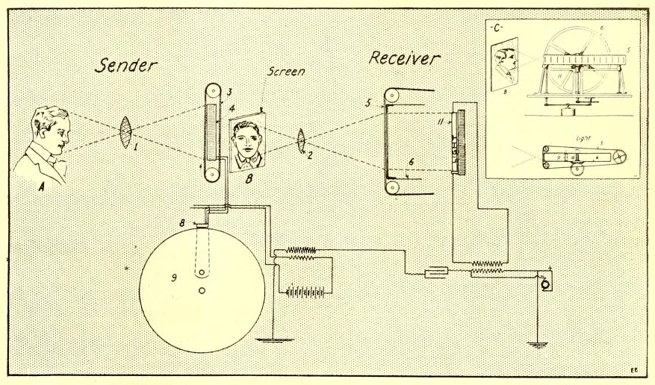

Fig. 1. This Is the Rothschild Telephot Scheme Which Cuts Up the Light Inpulses by Means of a Slotted Revolving Belt 3 at the Sender. Passing Rapidly Before the Selenium Dell 4 the Impulses Are Sent Over the Line and Influence a Source of Light 11 at the Receiver, Where a Similar Revolving Belt Scheme Reconstructs a Picture as Shown at B

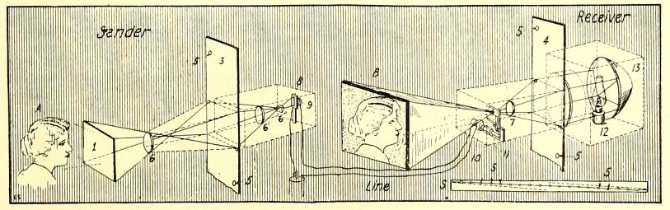

Fig. 2 Shows the A. C. & L. S. Andersen Telephot, Where Use Is Also Made of Revolving Belt 3, Having Perforations 5. This Belt at the Sender Rapidly Passes in Front of the Camera Influencing a Selenium Cell 9. At the Receiver a Sensitive Electro-Magnetic Arrangement, 10 and 11, Acting as a Shutter Cuts Off the Light Impulses; Thus Theoretically Reconstructing the Picture.

A clever telephot which was patented by Messrs. A. C. & L. S. Andersen is shown in Fig. 2. The sending apparatus comprises a dark chamber shown in dotted lines, in which is placed a lens 6’ which receives the rays issuing from the dark chamber. These rays after being refracted meet a small selenium cell 8, placed behind the prism 6“. Screen 1 represents an object (in reality farther removed from the dark chamber than the drawing indicates). The light rays coming from the screen 1 after refraction in the lens 6 which is in front of the dark chamber form upon the endless ribbon 3, a real image reversed and reduced by the screen 1, This ribbon is flat continuous and opaque except at certain perforated points, arranged according to a diagonal line as shown in the detail sketch 5. The distance separating the holes 5 depend upon the size of the image in the dark chamber. The holes are spaced apart in such a manner that only one point can be located at each instant within the field of the image in the dark chamber. The ribbon 3 is displaced from above downwardly by means of an electric motor ; it thus forms the end of the dark chamber: the luminous rays traversing the perforations of the ribbon fall upon the lens 6’ They are received by the selenium cell 8. Only one point comes at each instant within the field of the image as the illustration shows. When the ribbon has been displaced the whole of its length, each o: the points of’ perforation has crost tnr part of the image which is presented tc view ; thus, the entire picture is transmitted point by point.

At the receiving end we find the sender practically reversed. Here we have another moving ribbon 4 with perforated holes 5 In the dark chamber 13 we have a source of illumination which may be a kerosene lamp, or an electric lamp or any other kind of a lamp 12. This lamp throws itsrays thru lens 7. Here we have also the electro-magnet 10 which is connected with the selenium cell, and a battery at the senoing station. By means of an ingenious shutter arrangement 11, the light rays coming from the lamp 12 are more or less influenced, due to the fact that the electromagnet is more or less energized by the selenium cell 8 of the sender. In other words when at the sending station, the selenium cell was energized at its maximum, in this case the electro-magnet 10 a: the receiving end would be energized a: its maximum also, and therefore the shutter would let pass the maximum amount of light. All providing of course that the ribbon 4 was working synchronously with the ribbon 3 at the sender. As the ribbon 4 revolves very rapidly and synchronously with the ribbon at the sender, the picture is thus reproduced point by point and is recomposed upon the screen shown at B. Messrs. Anderson have also incorporated into this invention an ides showing how the picture can be transmuted in its actual colors. This is a very ingenious arrangement, but is outside of the scope of this article.

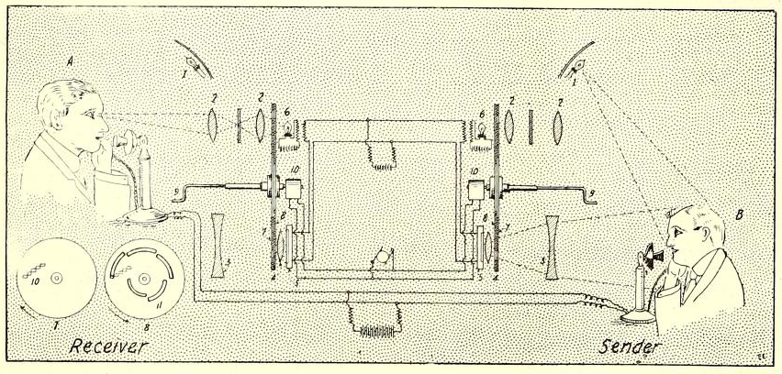

Fig. 3, the Hoglund Telephot Makes Use of Two Revolving Shutters, 7 and 8, Revolving in Opposite Directions. Selenium Cell 5 is Influenced by the Light Rays and the Picture at the Receiving Station Is Reconstructed by Means of the Light Variations of Lamp 6.

The next telephot, Fig. 3, was imagined by Gustav E. Hoglund, of Chicago, Ill. This invention also has been patented, and relates to that class of devices for cutting up and dividing light rays emanating from an image and causing them to act upon a selenium cell capable of changing its electrical resistance under light rays of different degrees of intensity. These vibrations are sent over a line and act upon a luminous center at the other end thereof, which may be in the form of a speaking arc and cause a fluctuation in the brilliancy of said arc which will cause light rays to emanate therefrom, said rays being of varying intensity according to the strength of the current. These rays will follow each other in the same order, and will be of comparatively the same intensity as the light rays emanating from the object. Hence, when the rays from the lamp are projected onto the retina of the eye in rapid succession, they will cause an image to be built up before the eye, which will be composed of the varying light rays of the same strength and in the same order as those emanating from the original image.

The device shown in Fig. 3 has a receiver and a sender ; each of the instruments comprises a selenium cell 5, positioned in front of which is the enlarging lens 4 and the reducing lens 3. Between these lenses is a double revolving shutter composed of discs 7 and 8. These are also shown in a detail sketch. Disc 7 has a series of square perforations 10, while disc 8 has a series of slots 11. It will be seen that as these discs revolve in opposite directions, each point of the picture is cut up successively and allowed to pass thru the optical lens system. Each of the receiving instruments also comprises a lamp 1 and enlarging lenses 2, 2. Between these lenses a ground glass plate is placed, upon which the final picture appears. Both receiving and sending instruments are connected by electrical lines as shown. The oppositely revolving discs are ordinarily actuated by means of the synchronous motor 10.

An interesting part of this invention is that these revolving shutters can be corrected if they do not run synchronously by means of handle 9. It becomes apparent that the two shutters must be brought into proper relation to one another ; it can be easily determined when such a relation is found by observing the image coming from the receiving instrument. If the shutters are not in proper relation, the image will be nothing more than a blur, and before it can be distinctly seen, the shutters will have to be in appropriate relation to bring the openings into the desired position. The inventor therefore provides handles 9 which extend from the shutters and by turning these handles, the shutters can be revolved until they are brought into proper relation with one another, the operator determining when such position has been reached by observing the completeness of the image reproduced by the receiving instrument. Once the shutters are in proper relation with one another, the motors are then supposed to operate them synchronously. By studying the illustration, it will be noted that the lamps 6 are varied into their proper luminosity due to the selenium cells 5 receiving more or less light.

While this scheme looks very feasible on paper, we are afraid that the lamps 6 will not respond instantaneously to the current variations in the selenium cells 5, and at best the picture would seem to us to be formed rather blurred.

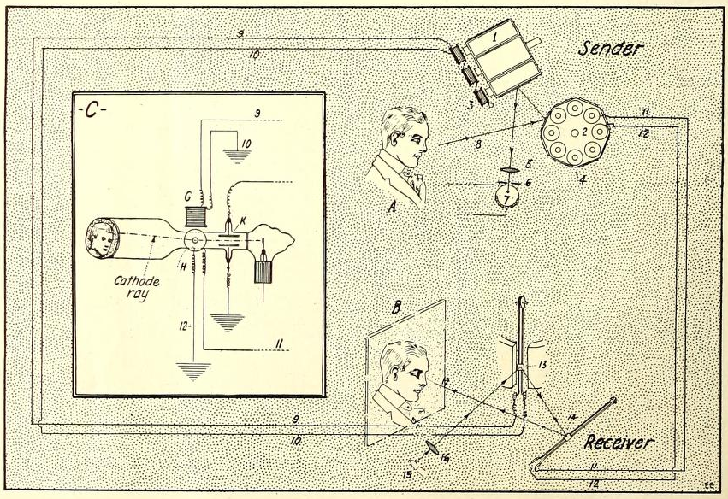

Fig. 4 Shows the Rosing Telephot. Use Is Made of Two Sets of Poly-Hedral Revolving Mirrors, 1 and 2, Throwing a Light Ray on Selenium Cell 7. At the Receiver Two Oscillographs Reconstruct the Picture Shown at B.

The next telephot which has also been patented in several countries is shown in Fig. 4. The inventor of this telephot is Boris Rosing of Petrograd, Russia. In order to eliminate the synchronous motor arrangements which have been the failure of almost all telephot schemes, Mr. Rosing does away entirely with them, substituting therefore a system comprising two oscillographs with movable reflecting surfaces.

This will be apparent further on. The optical system at the transmitting station comprises two polyhedral rotary mirrors, 1 and 2, the axis of rotation of which are at right angles to each other. They are driven at such speeds that the angular velocity of one of the mirrors is several times greater than the other ; and an objective or lens 5, the focal plane of which coincides with the plane of the screen 6 and the photo-electric receiver 7. The objective 5 is arranged in such a manner that rays emitted from any point of the field of vision arrive in the photo-electric receiver only after successive reflections by the two mirrors. When the mirrors 1 and 2 are rotated, the end 8 of the optical axis thus deflected traverses the field of the picture in a zig-zag path, so that from every portion thereof light is transmitted in a certain determinate order thru the opening of the screen 6 upon the photoelectric receiver 7. Permanent electric magnets carried by the mirrors 1 and 2 and stationary bobbins 3 together form small generators producing in the corresponding bobbins pulsating currents, the periodicity of which per revolution of the mirror corresponds to the number of reflecting surfaces thereof. The currents which are produced in the conductors 9, 10, 11, 12 and transmitted thru the receiving station are proportional to the components in the directions of the axes of a corresponding system of coordinates of angular movements which the optical axis 8 executes in the field of view.

At the receiving side we find two oscillographs provided with mirrors 13 and 14. The axes of both are arranged to correspond to the axes of rotation of the mirros 1 and 2. Lens 16 directs the rays proceeding from the luminous signaling point 15 on to the small mirror 13. There will therefore be imparted to the deflected optical axis 17 at the receiving station, the same movements in space which the deflected optical axis 8 at the sending station executes at the transmitting station. It goes without saying that the moving parts of the oscillographs naturally have much less inertia than do the revolving sets.

A different idea in Mr. Rosing’s invention is shown in insert C, Fig. 4. Here instead of using oscillographs, the inventor makes use of a cathode tube, the wires 9 and 10 from the revolving mirror sender 1 being connected to wires 9 and 10 which in turn go to an electro-magnet G. Wires 11 and 12 from revolving-mirror sender 2 go to 11 and 12 which are also connected to another electro-magnet H placed at right angles to electro-magnet G. A pencil of cathode rays is thrown upon the screen in back of the tube, and this ray is influenced by the electro-magnets H and G synchronously to the revolving mirrors 1 and 2 of the sender. Consequently a picture should be traced out on the screen of the cathode tube point by point, and it is conceivable that a perfect picture could be readily obtained by this means. A condenser K is also arranged in the cathode tube to steady the cathode rays, and for certain other purposes which it is not necessary to delve into in this article. This is a particularly clever invention, but we do not have any information on hand showing if it has ever been tried in practise. It certainly looks more promising than any of the others, particularly as it requires only four wires.

We must also mention a certain other type of telephot which strictly speaking is not a telephot at all in the ordinary sense of the word because it does not transmit pictures by electricity, but optically. It shows how a picture can be transmitted practically *by means of a single light ray.* This idea was patented by Mr. Alf Sinding-Larsen of Christiania, Norway. The idea is to have two mirrors vibrating at a different frequency of vibrations, which mirrors cut up the light ray into its components. For transmitting the pictures directly, the inventor makes use of a narrow tube with strongly reflecting inner surfaces which tube is arranged with its rear opening behind the light orifice in the transmitter. The optical system forming the image is arranged in such a manner that the rays form the individual image points across one another at a very acute angle. By this the inventor is enabled to cause the light taken up in the mouth of the tube to be transmitted thru the tube without being materially weakened in its passage to the other end of the tube and the image surface of the receiver.

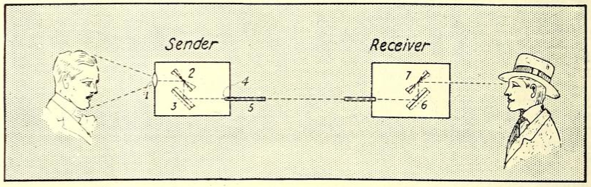

Fig. 5 Depicts the SindingLarsen Telephot. Two Mirrors Vibrating at Different Frequencies Cut Up the Light Rays. These Light Rays Are Past Thru a Metallic Tube Having Strong Reflecting Inner Surfaces. At the Receiver, the Light Rays Arer Past Thru a Similar System as the Sender and the Picture is Thus Reconstructed.

The synchronous movement of the mirrors is effected by coupling them in series the electro-magnets serving to keep the mirrors moving. Reference is made to Fig. 5, where the sender and the receiver are connected with the aforementioned reflection tube 5; 1 is an object lens of the receiving station camera in which are placed two mirrors 2 and 3. The mirror 2 oscillating very fast on an axis perpendicular to the plane of the drawing, while the mirror 3 oscillates more slowly on an axis lying on the same plane and is perpendicular to the axis of oscillation of mirror 2. By these means, the elements of the image formed by the lens 1 are in succession following a continuous zig-zag line transferred to the focus of a lens 4 placed in the opening of the reflection tube 5, said lens parallelizing the rays which meet the image point. At the receiver two similar mirrors 6 and 7 oscillating synchronously with the mirrors 1 and 3 respectively, throw the train of rays emerging from the reflection tube to the eye of an observer as indicated. The synchronous vibration of the respective pairs of mirrors is accomplished by ingenious means outside the scope of this article. It becomes apparent from this invention that by substituting for the lens 4 some electrical means such as a combination of selenium cell with a revolving shutter, pictures may thus be transmitted electrically without using reflection tubes such as are shown in 5.

In fact, a system of this sort was tried some years ago by the Russian inventor Szcepanich.

Any reader interested in the aforegoing patents, by sending a self-addrest envelop to the author can ascertain the numbers of the patents which have been discust in this article. Most of these patents are very ingenious, and contain a good deal of information on television which has not so far appeared in print outside of the patent office records.

1. Gernsback: “* Light entering the eye, influences the light-sensitive”rods and cones" of the retina, in some manner as yet not understood. The changes are supposed to be photochemical in their nature."
2. Gernsback: “The picture is actually transmitted at a distance. If the optical nerve is cut—the”wire" connecting the picture with the brain—we cannot “see” the picture, i.e., we will be blind."